# WDAS JACK AGENTS

AOSE 2017 CLASS

1. INTRODUCTION

This document needs to prepare the environment for the AOSE class.

2. REQUIREMENTS

1. V-REP EDU (Download it from <http://www.coppeliarobotics.com/downloads.html>)
2. JACK
3. Archive *AOSE-JACK-VREP-2017*.zip

3. INSTALLATION

1. Unzip the *AOSE-JACK-VREP-2017*.zip folder.

3.1 V-REP EXECUTION

1. Start V-REP.
2. Open the scene wharehouseStatic.ttt in the vrepFiles folder situated in the unzipped archive.

3.2 JACK EXECUTION AND COMPILATION

1. Open a terminal emulator (a CLI on Windows) and move into the folder target
2. Launch the script JDE: if you have Windows launch the .bat file, if you have Mac OS launch the .sh script and if you have Linux run the .sh file. For instance, on Macs use the following command:

$ ./JDE.sh

If it works, it will open the JDE (see figure 1)

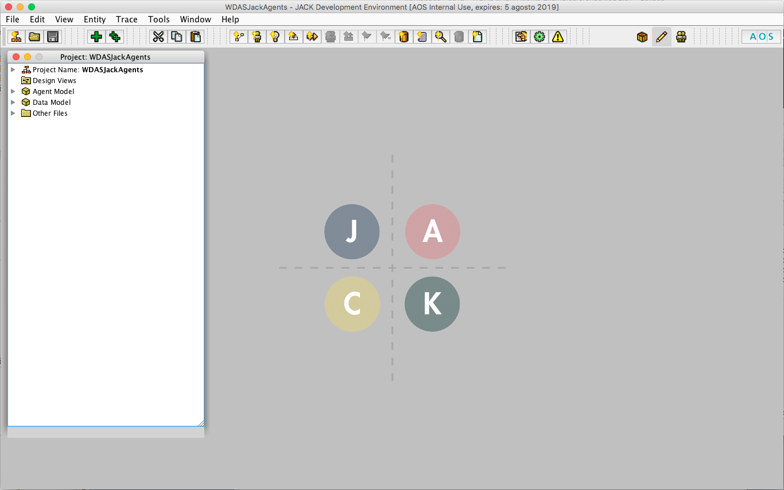

Figure 1

1. Open the Compiler Utility, in the Options add to the Project Java Properties

java.library.path = ./lib/lib/**x**

where **x** is one of the 3 folders in the **lib/lib** folder of the unzipped archive: macosx, x64 or x86 (choose the right one based on the operating system you use).

If there is another java.library.path remove it.

Check the Project Classpath as well. If there are more lines compare to the figure 2 remove them too.

The screen should look similar to this (figure 2):

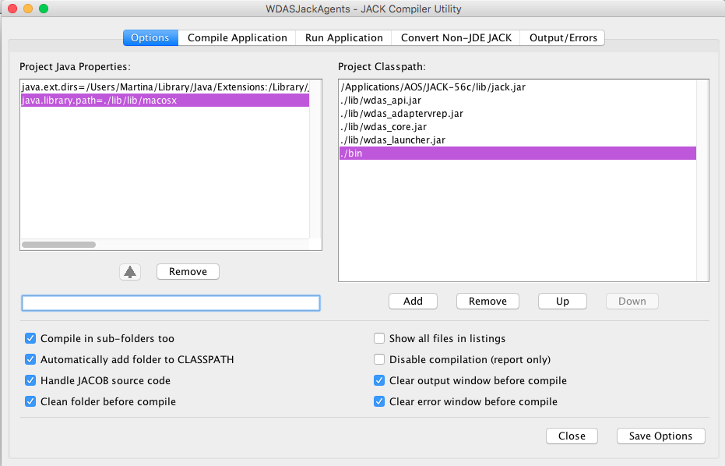

Figure 2

1. To run the code, go to the Run Application in the Compiler Utility and in the **select file** field write:

unitn.aose.warehousesim.launcher.Launcher

then click Run (figure 3).

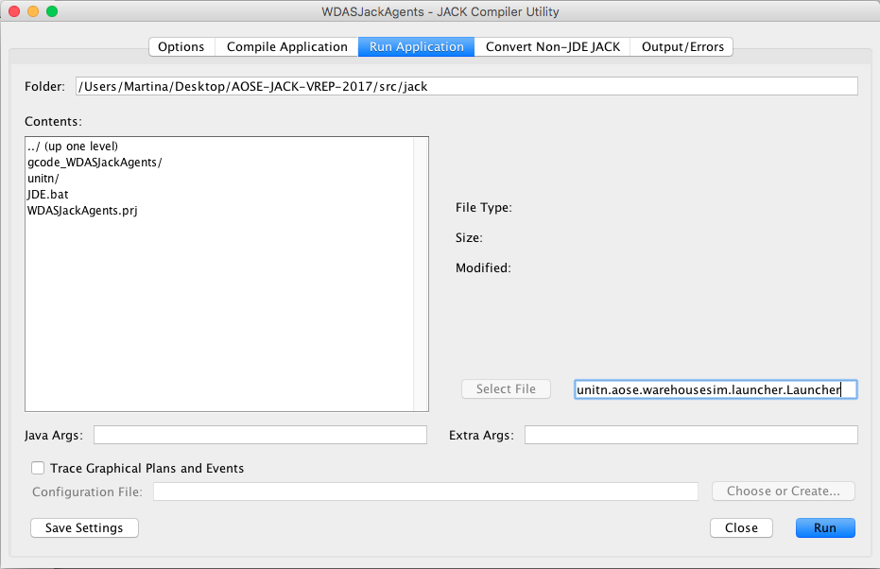

Figure 3

1. Remember to clean up and compile into the WDAS JACK Agents/src/jack folder.